Task 1.

<!DOCTYPE html>

<html lang="en">

<head>

  <meta charset="UTF-8">

  <meta name="viewport" content="width=device-width, initial-scale=1.0">

  <title>JavaScript Tasks</title>

</head>

<body>

  <h1>JavaScript Tasks</h1>

  <!-- Task 1: -->

  <script>

    alert("Hello, World!");

  </script>

</body></html>

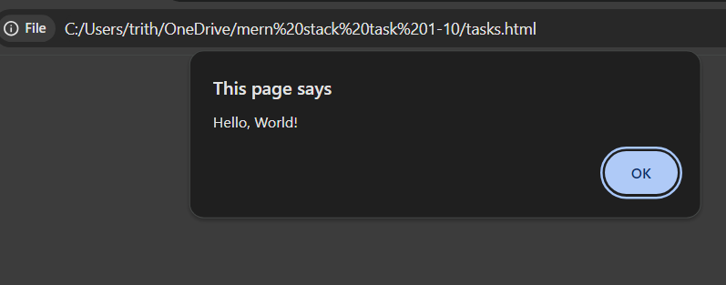

Task2.

<script>

  let stringExample = "Hello"; // String

    let numberExample = 42; // Number

    let booleanExample = true; // Boolean

    console.log("String :", stringExample);

    console.log("Number :", numberExample);

    console.log("Boolean :", booleanExample);

</script>

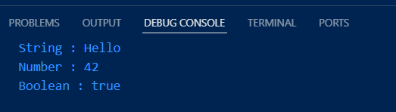

Task 3.

 <script>

  console.log("Addition:", 5 + 3);

    console.log("Subtraction:", 10 - 7);

    console.log("Multiplication:", 4 \* 3);

    console.log("Division:", 12 / 4);

</script>

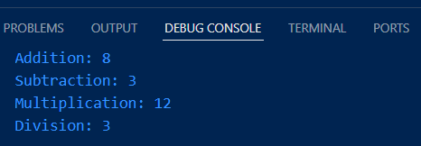

Task4.

<script>

 let firstName = "John";

    let lastName = "Doe";

    let fullName = firstName + " " + lastName;

    console.log("Full Name:", fullName);

</script>



Task5.

<script>

    let stringExample="hello";

    let numberExample=10;

    let booleanExample=true;

    console.log("Type of stringExample:", typeof stringExample);

    console.log("Type of numberExample:", typeof numberExample);

    console.log("Type of booleanExample:", typeof booleanExample);

</script>

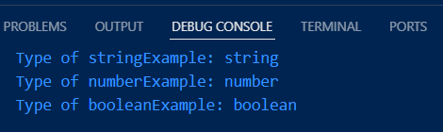

Task6.

/\*

      This is a multi-line comment.

    \*/

    // This is a single-line comment.

Task7.

<script>

    let a = 10;

    let b = 20 // Without semicolon

    let c = 30; // With semicolon

    console.log("a + b + c =", a + b + c);</script>

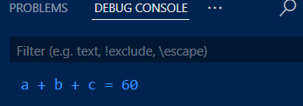

Task8.

<script>

    for (let i = 0; i < 2; i++) {

      console.log("Outer loop:", i);

      for (let j = 0; j < 2; j++) {

        console.log("  Inner loop:", j);

      }

    }

  </script>

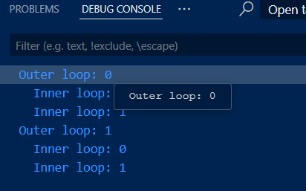

Task9.

<script>

    let x = 1, y = 2, z = 3;

    console.log("x:", x, "y:", y, "z:", z);

  </script>

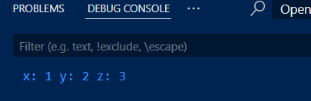

Task10.

<script>

    console.log("Script at the bottom of the body executes last.");

  </script>

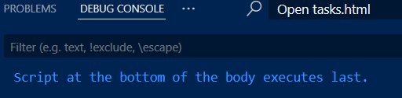

Task11.

<script>

    undeclaredVariable = "This works without 'use strict'";

    console.log(undeclaredVariable);

</script>

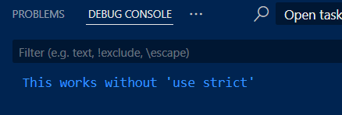

Task12.

<script>

    "use strict";

    undeclaredVariable = "This works without 'use strict'";

    console.log(undeclaredVariable);

  </script>

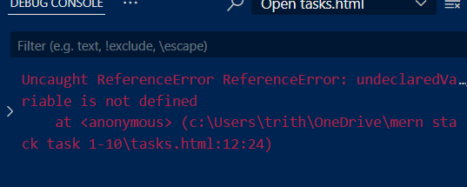

Task13.

<script>

    "use strict";

    let myVariable = "Cannot delete this in strict mode";

    function myFunction(param) {

      return param;

    }

    console.log("In 'use strict', deleting variables, functions, or parameters throws an error.");

  </script>

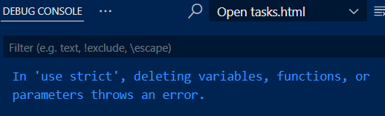

Task14.

<script>

    undeclaredWithoutStrict = "This works without strict mode";

    console.log("Without 'use strict':", undeclaredWithoutStrict);

    "use strict";

    console.log("With 'use strict', assigning undeclared variables throws an error.");

  </script>

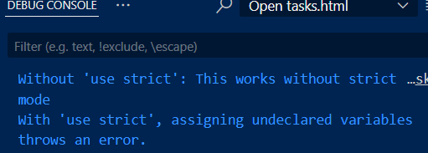

Task15.

 <script>

    "use strict";

    console.log("Task 15 - In 'use strict', reserved keywords cannot be used as variable names.");

  </script>

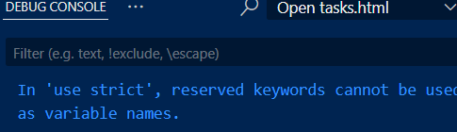

Task16.

<script>

var varVariable = "Declared using var";

    let letVariable = "Declared using let";

    const constVariable = "Declared using const";

    console.log( varVariable);

    console.log(letVariable);

    console.log(constVariable);

  </script>

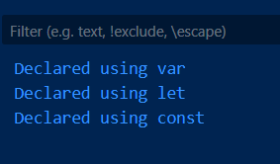

Task16.

 <script>

    const h="hello";

    console.log(h);

    h="hii";

    console.log(h);

  </script>

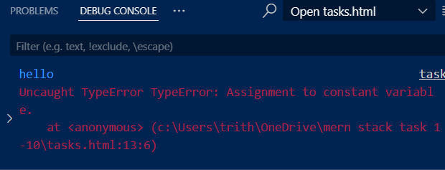

Task18.

<script>

    let uninitializedVariable;

    console.log(uninitializedVariable);

  </script>

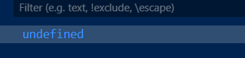

Task19.

<script>

    let mixedVariable;

    mixedVariable = 42;

    console.log(typeof mixedVariable);

    mixedVariable = "Hello, World!";

    console.log(typeof mixedVariable);

    mixedVariable = true;

    console.log(typeof mixedVariable);

  </script>

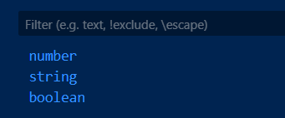

Task20.

<script>

    let originalName = "Original Name";

    let renamedName = originalName;

    console.log(originalName);

    console.log(renamedName);

    renamedName = "Updated Value";

    console.log( originalName);

    console.log(renamedName);

  </script>

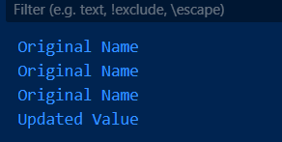

Task21.

<script>

    let stringVar = "Hello, World!";

    let numberVar = 42;

    let booleanVar = true;

    let nullVar = null;

    let undefinedVar;

    let objectVar = { key: "value" };

    console.log("String:", stringVar);

    console.log("Number:", numberVar);

    console.log("Boolean:", booleanVar);

    console.log("Null:", nullVar);

    console.log("Undefined:", undefinedVar);

    console.log("Object:", objectVar);

  </script>

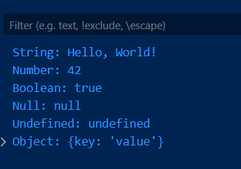

Task22.

<script>

    let stringVar = "Hello, World!";

    let numberVar = 42;

    let booleanVar = true;

    let nullVar = null;

    let undefinedVar;

    let objectVar = { key: "value" };

    console.log(typeof stringVar);

    console.log(typeof numberVar);

    console.log(typeof booleanVar);

    console.log(typeof nullVar);

    console.log(typeof undefinedVar);

    console.log(typeof objectVar);

  </script>

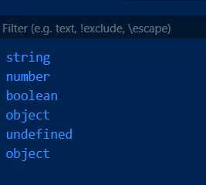

Task23.

<script>

    let symbolVar = Symbol("hello");

    console.log(typeof symbolVar);

  </script>

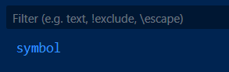

Task24.

<script>

    let nullExample = null;

    console.log(nullExample);

    console.log(typeof nullExample);

  </script>

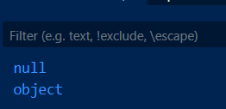

Task25.

<script>

    var varScoped = "var is function-scoped";

    function show()

    {

        let letScoped = "let is block-scoped";

      console.log(varScoped);

      console.log(letScoped);

    }

    show();

  </script>

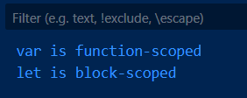

Task26.

<script>

    let stringNum = "42";

    let implicitConversion = stringNum \* 1;

    console.log( implicitConversion);

    let explicitConversion = Number(stringNum);

    console.log(explicitConversion);

  </script>

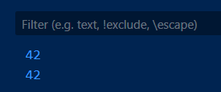

Task27.

<script>

     let booleanValue = true;

    let booleanToString = String(booleanValue);

    console.log(booleanToString);

    let stringToBoolean = Boolean("false");

    console.log(stringToBoolean);

  </script>

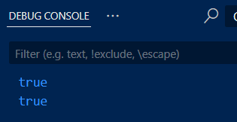

Task28.

<script>

    let a1 = 2;

    let b1 = 3;

    console.log("Addition," ,a1 + b1);

    console.log("Subtraction ", a1 - b1);

    console.log("Multiplication ", a1 \* b1);

    console.log("Division ", a1 / b1);

    console.log("Modulo ", a1 % b1);

    console.log("expo",a1\*\*b1);

  </script>

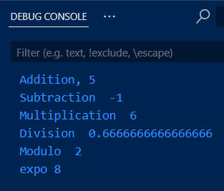

Task29.

<script>

    let c1 = 5;

    console.log(c1);

    c1++; //increment by 1

    console.log(c1);

    c1--; // Decrement by 1

    console.log(c1);

  </script>

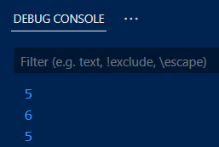

Task30.

let precedenceResult = 10 + 5 \* 2 - (3 / 3); console.log("Operator precedence", precedenceResult);

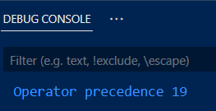

Task31.

<script>

    let num1 = 10, num2 = 20;

        console.log(num1 > num2); // false

        console.log(num1 < num2); // true

        console.log( num1 >= num2); // false

        console.log( num1 <= num2); // true

</script>

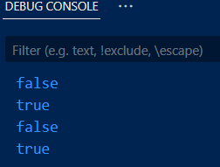

Task32.

<script>

let num1 = 10, num2 = 20;

        let strNum = "10";

        console.log(num1 == strNum); // true

        console.log( num1 === strNum); // false

</script>

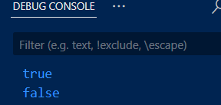

Task33.

<script>

let str1 = "apple", str2 = "banana";

        console.log(str1 < str2); // true

        console.log( str1 > str2); // false

        console.log(str1 === str2); // false

</script>

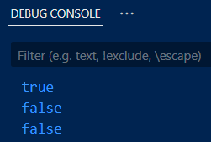

Task34.

<script>

 let val1 = 5, val2 = "5";

        console.log(val1 != val2); // false

        console.log(val1 !== val2); // true

</script>

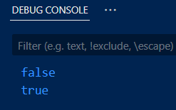

Task35.

<script>

 console.log(null == undefined); // true

 console.log(null === undefined); // false

</script>

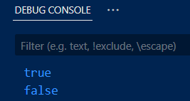

Task36.

 <script>

   let num = 7;

        if (num % 2 === 0)

        {

           console.log( num, "is even.");

        }

        else

        {

          console.log( num, "is odd.");

        }

  </script>

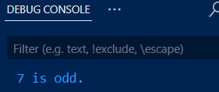

Task37.

 <script>

   let num = 7;

   let number = -5;

        if (number > 0)

        {

          console.log(number, "is positive.");

        }

        else

        {

           if (number < 0)

           {

              console.log(number, "is negative.");

           }

           else

           {

              console.log(number, "is zero.");

           }

        }

  </script>

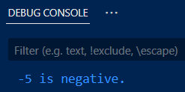

Task38.

<script>

      let age = 18;

    let status = age >= 18 ? "Adult" : "Minor";

    console.log("Age status:", status);

  </script>

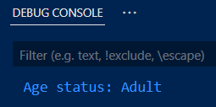

Task39.

<script>

    let variable;

    let isValid = variable ? "Valid" : "Invalid";

    console.log("Variable validity:", isValid);

  </script>

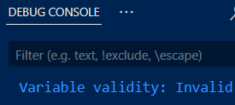

Task40.

<script>

    let score = 85; // Change this value to test

    let grade = score >= 90

      ? "A"

      : score >= 80

      ? "B"

      : score >= 70

      ? "C"

      : score >= 60

      ? "D"

      : "F";

      console.log(grade);

      </script>

  </script>

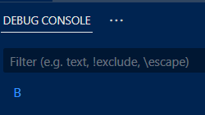

Task41.

<script>

        console.log(true && true);

        console.log(true && false);

        console.log(true || false);

        console.log(false || false);

        console.log(!true);

        console.log(!false);

    </script>

  </script>

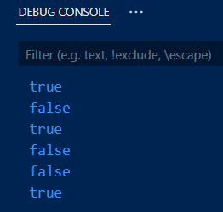

Task42.

<script>

        let nums = 15;

        let isInRange = nums >= 10 && nums <= 20;

        console.log(nums, "is in range and is", isInRange);

  </script>

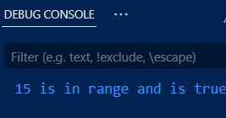

Task43.

<script>

        let isAvailable = true;

        let isNotAvailable = !isAvailable;

        console.log(isAvailable);

        console.log(isNotAvailable);

  </script>

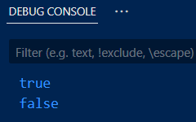

Task44.

<script>

        let shortCircuitAnd = false && console.log("This won't be logged");

        let shortCircuitOr = true || console.log("This won't be logged");

        console.log(shortCircuitAnd);

        console.log(shortCircuitOr);

  </script>

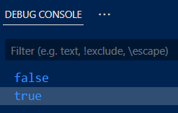

Task45.

<script>

        console.log('apple' && 'banana');

        console.log('' || 'fallback');

        console.log(null || undefined);

        console.log( 0 && 1);

  </script>

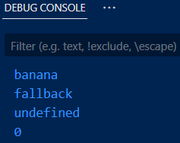

Task46.

<script>

        function sum(a, b) {

          return a + b;

        }

        console.log("Sum:", sum(5, 10));

  </script>

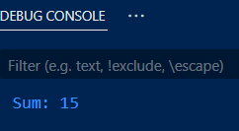

Task47.

<script>

        function calculateRectangleArea(length, width) {

          return length \* width;

        }

console.log("Area of a rectangle is", calculateRectangleArea(5, 3));

  </script>

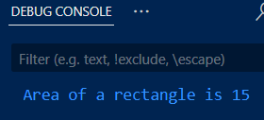

Task48.

<script>

       function greet() {

          console.log("Hello, welcome to JavaScript functions!");

        }

        greet();

  </script>

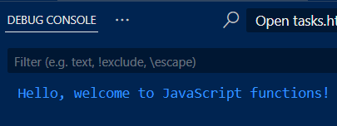

Task49.

<script>

        function doNothing(){}

        let result = doNothing();

        console.log(result);

  </script>

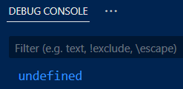

Task50.

<script>

        function greetUser(name = "Guest")

        {

          console.log(`Hello, ${name}!`);

        }

        greetUser("Alice");

        greetUser();

  </script>

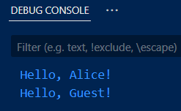

Task51.

<script>

const greet = (name) => `Hello, ${name}!`;

console.log(greet("Alice"));

console.log(greet("Bob"));

  </script>

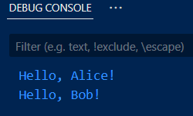

Task52.

<script>

const add = (a, b) => a + b;

console.log(add(3, 5));

console.log(add(-2, 4));

console.log(add(10, 20));

  </script>

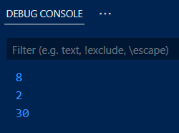

Task53.

<script>

    const isEven = (num) => num % 2 === 0;

console.log(isEven(4));

console.log(isEven(7));

console.log(isEven(0));

  </script>

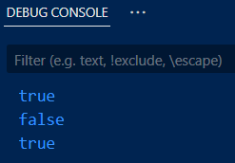

Task54.

<script>

 const maxValue = (a, b) => {

  return a > b ? a : b;

};

console.log(maxValue(10, 20));

console.log(maxValue(50, 25));

console.log(maxValue(7, 7));

  </script>

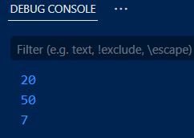

Task55.

<script>

     const myObject = {

  value: 10,

  multiplyTraditional: function (num) {

    return this.value \* num;

  },

  multiplyArrow: (num) => {

    return this.value \* num;

  }

};

console.log(myObject.multiplyTraditional(2));

console.log(myObject.multiplyArrow(2));

  </script>

